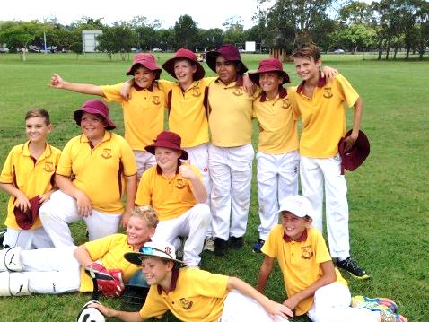
WRPS BOYS’
CRICKET TEAM

The senior boys’ cricket team played their first match of the PSSA Knockout round against Lennox Head at Barry Davidson Oval on Tuesday. We lost the toss and batted with a damp and slow outfield. Lennox Head bowled very tightly, yielding only a few extras and after 12 overs WRPS was only 14 runs, with the loss of 2 wickets. We were finally bowled out for 40 in the 21st over.
Our team bowled very well and some fantastic efforts in the field meant we were able to dismiss Lennox Head by the final ball of the match. Unfortunately for WRPS, Lennox Head scored 78 runs and will now progress to Round 2.
The Lennox Head coach commented on the great spirit in which our boys played the game, even after our score had been reached. Well done to all players, and thank you to Zac W dad for scoring.

By Mr Shaw

The boys’ cricket team played against Lennox Head on Tuesday. We lost the toss and were sent in to bat first. We started off very slowly with 2 for 16. When we came back to bat, we lost 2 early wickets but tried our best resulting in 40 all out. Lennox Head came out to bat with no fear but after 2 quick wickets they decided to bat slower. After drinks they were 5 for 40 with 1 run to get in 12 overs. They got the 1 run but we got to play the whole 25 overs and bowled them out for 73 runs. We would like to thank Mr Shaw for coaching us.

By Thomas and Kane

